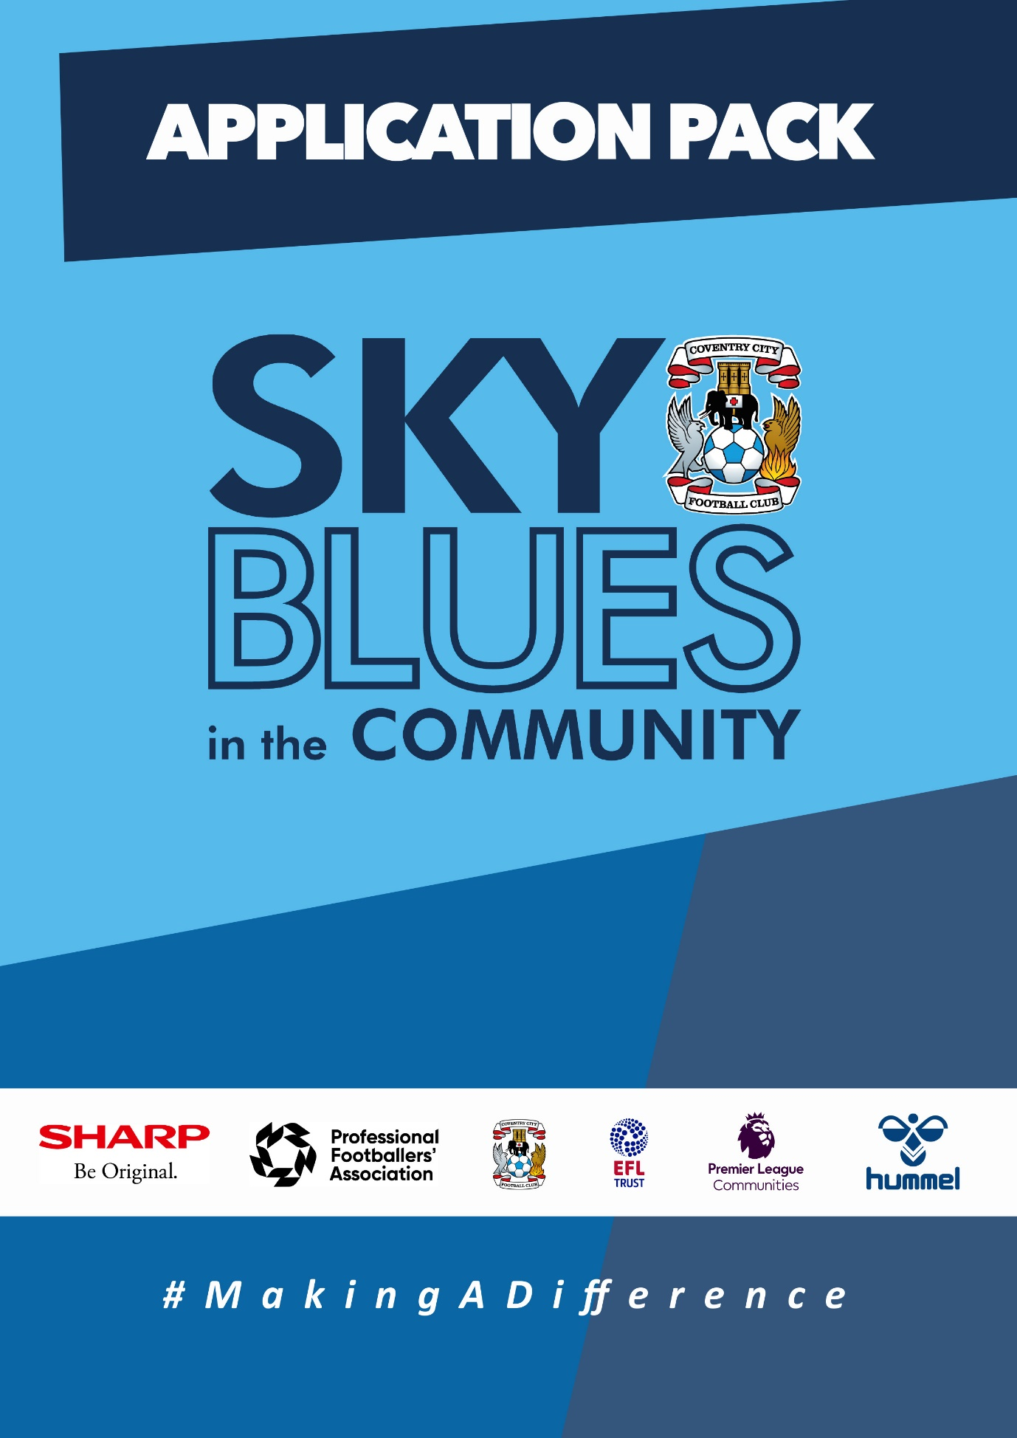

APPLICATION PACK

ABOUT US
Sky Blues in the Community (SBitC) is the official charity arm of Coventry City Football Club, based at the Coventry Building Society Arena. We are committed to harnessing the power of sport and physical activity and utilising Coventry City Football Club’s unique influence and appeal to develop and deliver high quality community programmes and form strategic alliances that empower the people of Coventry and Warwickshire. We provide meaningful opportunities for improved health and wellbeing, enhanced social inclusion, reduced crime involvement, and expanded access to education and training, we will #MakeADifference in our city and county.
The work of Sky Blues in the community is currently categorised under three core themes, each with their own headline goal.
Health and Wellbeing – We will play our part, standing shoulder to shoulder with a host of partners, in combatting the social challenges that currently risk the health and wellbeing of Coventry and Warwickshire’s most underrepresented communities. We will strive to deliver top quality, engaging and impactful community-based programmes that support members of Coventry and Warwickshire to pursue a happier and healthier life.
Education, Skills and Training – We will be integral in improving the training and employment opportunities available in Coventry and Warwickshire by inspiring our people, helping to provide the tools, experiences and guidance needed to build and sustain a prosperous career.
Inclusion, Engagement and Participation – We will create a more active and cohesive Coventry and Warwickshire, giving those that call it home the opportunity to participate in physical activity, enabling everyone to access the benefits of regular exercise barrier-free in an unjudged, welcomed and inspiring way.
People and Infrastructure – We simply could not achieve the impact we do without the dedication and expertise of our people, working tirelessly to ensure the hard-to-reach are reachable. In expanding our scope and deepening our offer, we also need to invest in our people, our foundation and infrastructure. We will ensure that our infrastructure and resources match our ambition, and our staff are representative of our community, ensuring they have access to high quality learning and development opportunities, enabling them to learn new skills and realise their own potential.

The values that we expect our staff to demonstrate at all times are as follows.
- Community Focused
- Passionate
- Innovative
- Ambitious
- Inclusive
Sky Blues in the Community are committed to embracing and fostering equality, diversity and inclusion in the workplace as well as in the delivery of its services, activities, and programmes, by promoting a positive organisational culture that values all staff and service users. We will strive to create an inclusive environment where everyone feels able to participate and achieve their potential.
Sky Blues in the Community operates a person-centred approach to safeguarding and where concerns about the welfare of a child or adult at risk exists, staff will always act with their best interests in mind. Sky Blues in the Community fully acknowledges and accepts its responsibility for the well-being and safety of all children and adults at risk engaged in Trust activities. It is the duty of all staff working at the Trust to ensure they safeguard children and adults at risk by creating an environment that protects them from harm. Safeguarding is everyone’s responsibility.

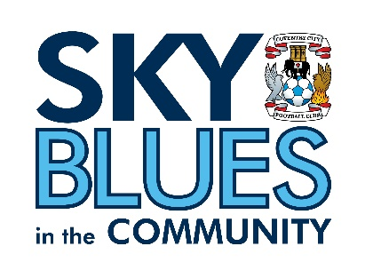

JOB DESCRIPTION
Job Title: | Football Development Coordinator | Reporting to: | Football Development Manager
Salary: | £26,000 | Contract Type: | Full time – 37.5 hours per week
Location: | President Kennedy School, Rookery Lane, Coventry, CV6 4GL | Days and hours of work: | Hours to be confirmed at interview and with job offer.
Document created: | January 2024 | Reference number: | SBITC-FDC

Purpose of the role:

We are seeking a dynamic and dedicated Football Development Coordinator to join our Player Development Centre (PDC). As the Football Development Coordinator, you will play a pivotal role in shaping the future of young football talents within our Charity.

The Post holder will be tasked to develop our work within the local community and partners, and will be responsible for numerous football development projects. These will include coaching and managing on our football education academy in partnership with Coventry College.

Whilst also Supporting Football Development Manager with all aspects of our Player Development Centre’s.

The Football Development Coordinator plays a crucial role in shaping the future of the centre by cultivating a nurturing environment that maximizes the potential of players and coaches at all levels.

The role key part is to ensure quality assurance is met to a high standard. Quality assurance is crucial for fostering a productive and effective learning environment. Coaches play a pivotal role in ensuring that training sessions adhere to established standards, focusing on skill development, tactical understanding, and physical conditioning. Regular assessments of players’ progress help maintain high-quality training programs, identifying strengths and areas for improvement.

In a our player development centre, the role of quality assurance involves ensuring that training programs, coaching methods, and facilities meet established standards. This includes monitoring player development, assessing coaching effectiveness, and maintaining a high standard of performance to enhance the overall quality of the program.

This role will require a dynamic facilitator and effective organiser who has experience of working with young people individually and in a group setting. The Post holder will need to show initiative and be able to develop a Programme of work.

This post is a varied position which will involve project management, relationship building, facilitating and evaluating several Programme of work.

Key responsibilities (but not completely exclusive to):

- Player Development: Design and implement comprehensive training programs to enhance the technical, tactical, and physical skills of players within the Player Development Centre.

- Curriculum Design: Develop a progressive and age-appropriate football curriculum that aligns with the club’s philosophy and ensures the holistic development of players.

- Player Assessment: Implement a robust player assessment system to regularly evaluate and monitor the progress of individuals, identifying areas for improvement and creating tailored development plans.

- Talent Identification: Collaborate with scouts and other stakeholders to identify and recruit promising young talents for the Player Development Centre.

- Parental Communication: Establish effective communication channels with parents, providing regular updates on player development, performance, and addressing any concerns or queries.

- Collaboration with Academy Teams: Work closely with the academy teams to ensure a smooth transition for players progressing through the development pathway.

- Community Engagement: Organise and participate in community events, workshops, and outreach programs to promote the Player Development Centre and foster community involvement in football development.

- Strategic Planning: Develop and implement a strategic plan for the PDC, outlining short-term and long-term objectives in line with the organization’s football development strategy.

- Budget Management: Manage the budget for the PDC, allocating resources effectively to support coaching staff, facilities, equipment, and other necessary components of player development.

- Coaching Staff Leadership: Lead and manage the coaching team, providing guidance, mentorship, and professional development opportunities to ensure a high standard of coaching within the PDC.

- Player Recruitment: Oversee the player recruitment process, working closely with scouts and coaches to identify and recruit talented young players who align with the club’s philosophy.

- Compliance and Regulations: Stay informed about relevant football regulations and ensure that the PDC operates in compliance with governing bodies’ guidelines.

- Facility Management: Oversee the maintenance and usage of training facilities, ensuring a safe and conducive environment for player development activities.

- Football Education Academy – Lead on the football side of our 16-19 year old academy in partnership with Coventry College.

- PDC Games Programme – Support with the coordination of the games programme including allocation of venues and referees.

- Tournaments:- Organisation and Coordination of Tournaments

PERSON SPECIFICATION
Job Title: Football Development Coordinator
Qualifications | Essential | Desirable | Method
Football UEFA B Qualification (or currently enrolled / working towards) | √ |  | Application
Sports coaching qualifications in other sports |  | √ | Application
Coaching Disabled Footballers Award or equivalent inclusive sports coaching qualification. |  | √ | Application
Talent Identification Qualification |  | √ | Application
FA Safeguarding qualification | √ |  | Application
FA Emergency First Aid or equivalent qualification | √ |  | Application

Knowledge | Essential | Desirable | Method
Knowledge of Football Player pathway | √ |  | Application/Interview
Understanding of Safeguarding and Health and Safety requirements in community and educational settings | √ |  | Application/Interview
Knowledge of business development and financial awareness |  | √ | Application

Skills | Essential | Desirable | Method
Able to communicate in writing and verbally with a wide range of people | √ |  | Application/Interview
Able to work as part of a team and on own initiative | √ |  | Interview
Able to adapt coaching sessions to meet participant needs | √ |  | Application/Interview
Able to motivate, encourage and enthuse young people to participate in sessions | √ |  | Application/Interview
Excellent planning and organisational skills | √ |  | Application/Interview
Excellent customer service skills | √ |  | Application/Interview
Advanced IT skills to include Microsoft Office packages and monitoring and evaluation and booking software | √ |  | Application/Interview
Able to lead and manage people | √ |  | Application/Interview

Experience | Essential | Desirable | Method
A minimum of 4 years football coaching experience | √ |  | Application/Interview
Experience of monitoring and evaluating the effectiveness of player development | √ |  | Application/Interview
Experience of recruiting, leading and managing a team of staff/volunteers | √ |  | Application/Interview
Experience of managing an income generating project or programme | √ |  | Application/Interview
Experience of developing and managing a budget |  | √ | Application/Interview
Experience of managing relationships with multiple stakeholders | √ |  | Application/Interview

Personal | Essential | Desirable | Method
Passionate about using the power of sport to make a difference in peoples lives | √ |  | Application/Interview
Ambitious and driven individual | √ |  | Interview
A solution focused and flexible attitude to work and wiling to work unsociable hours as and when required | √ |  | Application/Interview
Hold a valid driving license and have access to own vehicle | √ |  | Application/Interview
Reliable and dependable | √ |  | Application/Interview

APPLICTION INFORMATION
Sky Blues in the Community is committed to the safeguarding of its staff, volunteers, and participants. Any job offer made is subject to satisfactory references and a disclosure and barring service (DBS) check. Application forms for this position is available from the CCFC website.
To apply for this role, please send a CV and covering letter or completed application form detailing how you meet the requirements of this role as set out in the person specification to Shaun.pierce@sbitc.org.uk
Closing date for applications: Friday 23rd February 2024
Please note that we plan to interview for this position at the end of W/C 26thFebruary 2024 so please make sure you will be available as we will have limited ability to reschedule.

Please note: Our goal is to identify the most qualified individual for the role. As a result, we may close the job application process if we find a suitable candidate before the originally specified deadline.

Privacy Notice
Sky Blues in the Community is committed to being transparent about how it handles your personal information, to protecting the privacy and security of your personal information and meeting its obligation under the General Data Protection Regulation and the Data Protection Act 2018. For more information or a copy of our privacy policy please email sbitc@sbitc.org.uk.
SBITC is an equal opportunities employer and welcomes applications from all sections of the community. All appointments will be made based on merit.
The following policies are available Community - Coventry City (ccfc.co.uk) -Privacy Policy -Safeguarding Policy
Equality, Diversity and Inclusion Policy
GDPR/Data Protection Policy
Safer Recruitment

