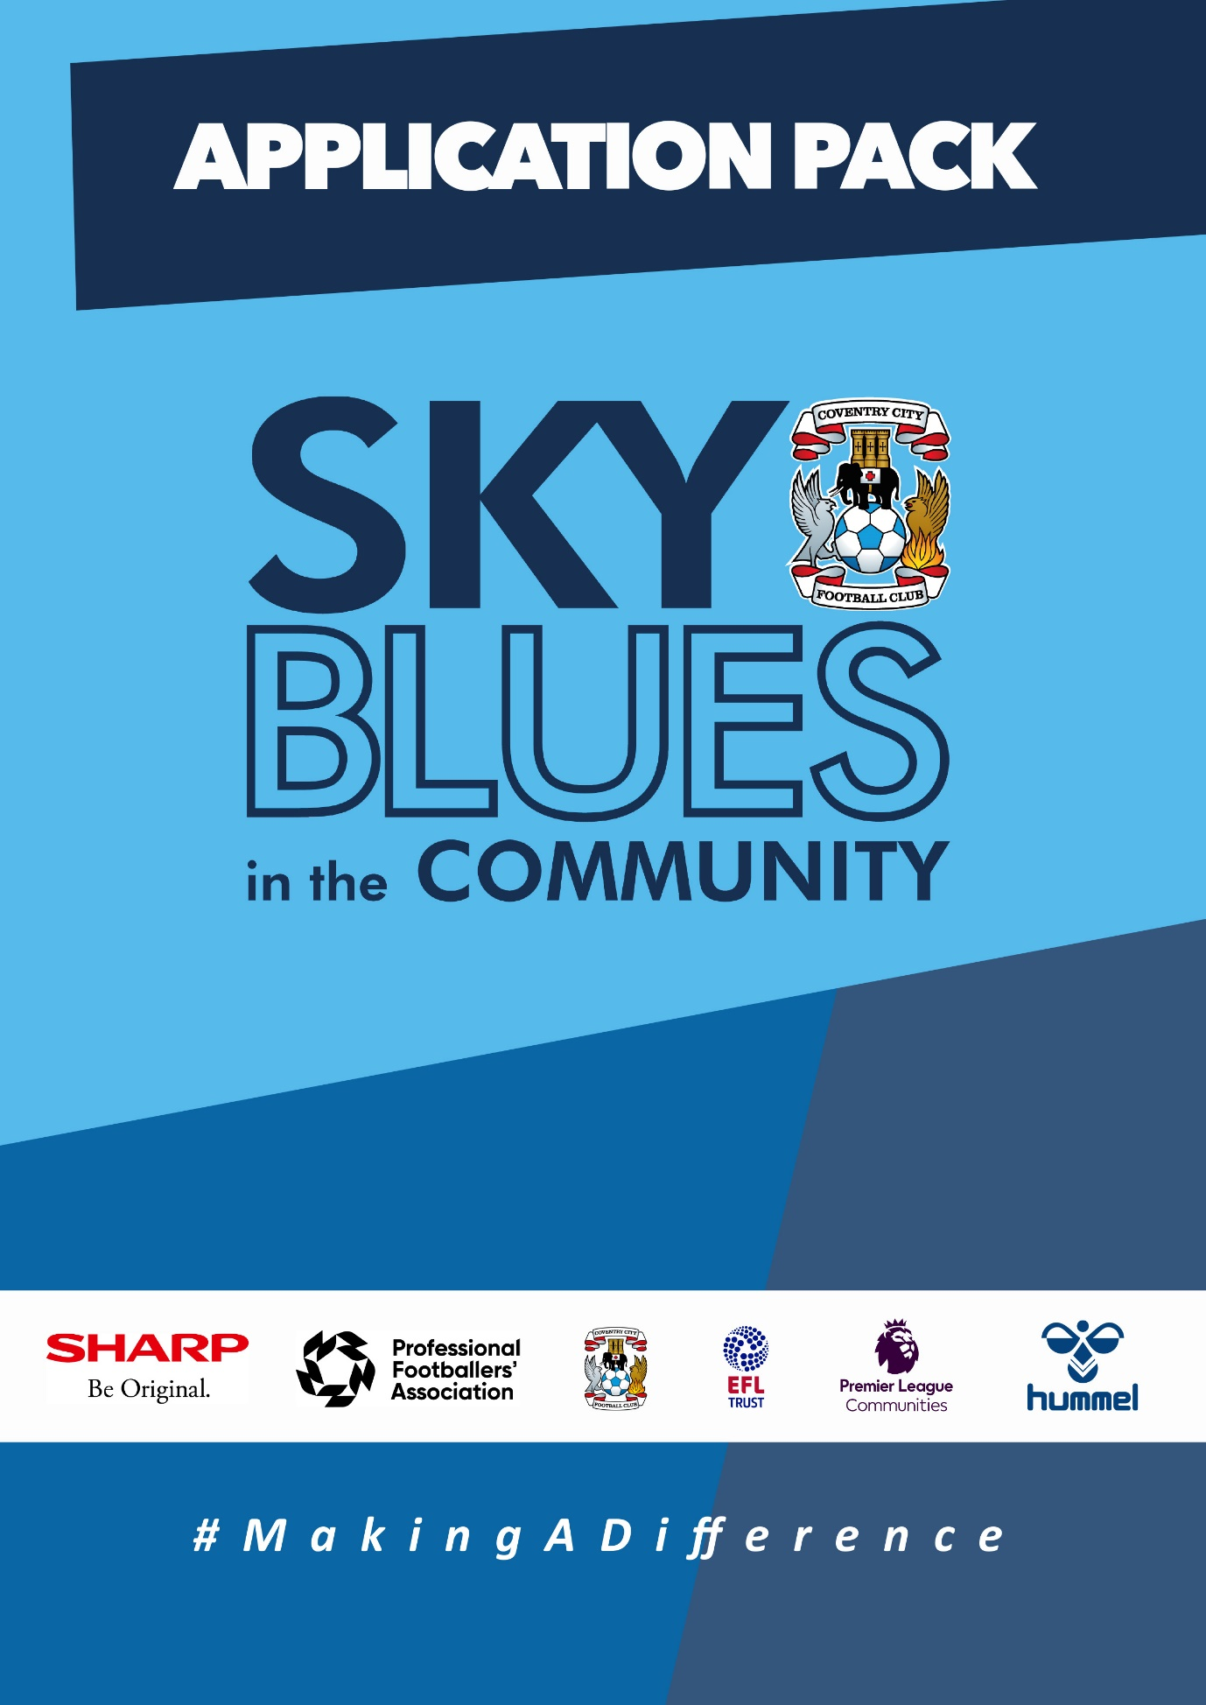

APPLICATION PACK

ABOUT US
Sky Blues in the Community (SBitC) is the official charity arm of Coventry City Football Club, based at the Coventry Building Society Arena. We are committed to harnessing the power of sport and physical activity and utilising Coventry City Football Club’s unique influence and appeal to develop and deliver high quality community programmes and form strategic alliances that empower the people of Coventry and Warwickshire. We provide meaningful opportunities for improved health and wellbeing, enhanced social inclusion, reduced crime involvement, and expanded access to education and training, we will #MakeADifference in our city and county.
The work of Sky Blues in the community is currently categorised under three core themes, each with their own headline goal.
Health and Wellbeing – We will play our part, standing shoulder to shoulder with a host of partners, in combatting the social challenges that currently risk the health and wellbeing of Coventry and Warwickshire’s most underrepresented communities. We will strive to deliver top quality, engaging and impactful community-based programmes that support members of Coventry and Warwickshire to pursue a happier and healthier life.
Education, Skills and Training – We will be integral in improving the training and employment opportunities available in Coventry and Warwickshire by inspiring our people, helping to provide the tools, experiences and guidance needed to build and sustain a prosperous career.
Inclusion, Engagement and Participation – We will create a more active and cohesive Coventry and Warwickshire, giving those that call it home the opportunity to participate in physical activity, enabling everyone to access the benefits of regular exercise barrier-free in an unjudged, welcomed and inspiring way.
People and Infrastructure – We simply could not achieve the impact we do without the dedication and expertise of our people, working tirelessly to ensure the hard-to-reach are reachable. In expanding our scope and deepening our offer, we also need to invest in our people, our foundation and infrastructure. We will ensure that our infrastructure and resources match our ambition, and our staff are representative of our community, ensuring they have access to high quality learning and development opportunities, enabling them to learn new skills and realise their own potential.
The values that we expect our staff to demonstrate at all times are as follows.
- Community Focused
- Passionate
- Innovative
- Ambitious
- Inclusive
Sky Blues in the Community are committed to embracing and fostering equality, diversity and inclusion in the workplace as well as in the delivery of its services, activities, and programmes, by promoting a positive organisational culture that values all staff and service users. We will strive to create an inclusive environment where everyone feels able to participate and achieve their potential.
Sky Blues in the Community operates a person-centred approach to safeguarding and where concerns about the welfare of a child or adult at risk exists, staff will always act with their best interests in mind. Sky Blues in the Community fully acknowledges and accepts its responsibility for the well-being and safety of all children and adults at risk engaged in Trust activities. It is the duty of all staff working at the Trust to ensure they safeguard children and adults at risk by creating an environment that protects them from harm. Safeguarding is everyone’s responsibility.

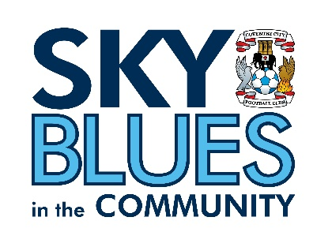

JOB DESCRIPTION
Job Title: | Apprentice Sports Coach  Communicator Activator Coach Level 2 Apprenticeship | Reporting to: | Operations Manager
Salary: | £11,700 per annum (£6p/h x 37.5 hours per week) | Contract Type: | Full time (minimum 32 hours per week)
Location: | Across Coventry and Warwickshire | Days and hours of work: | Hours to be confirmed at interview and with job offer.  Hours will be Monday – Saturday between 9am-8pm
Document created: | October 2023 | Reference number: | SBITC-ASC

Purpose of the role:

The post holder will assist with the planning, delivery and evaluation of sport and physical activity sessions to children, young people and adults across a variety of community based programmes. The post holder will ensure all sessions are delivered to the highest possible standard by following the Sky Blues in the Community quality assurance framework.
Key responsibilities (but not completely exclusive to):

- Assist with the planning, delivery and evaluation of
- a variety of age-appropriate sport and physical activity coaching sessions to meet the needs of groups and individuals in accordance with the Sky Blues in the Community programme.
- Work in diverse settings, such as community settings, youth clubs, leisure centres, public parks and open spaces, schools and colleges
- Undertake administrative tasks related to the sessions that you are responsible for including updating registers, consent forms, risk assessments, incident and accident forms, writing case studies and social media posts that demonstrate impact of projects, and recording any outcomes and accreditations achieved by participants using relevant monitoring and evaluation systems.
- Work with individuals and/or groups from a range of backgrounds, abilities, and age ranges
- Be responsible for the correct use of and safe keeping of sport and physical activity equipment.
- Ensure that the safety of facilities is checked before and during use for practical participation.
- Build and support positive working partnerships with existing/new key partners to receive continued funding for delivery of programmes.
- Maintain high standards of professional behaviour towards colleagues, young people, and adults with whom we engage and the wider public when working for and wearing Sky Blues in the Community uniform.
- Maintain an up-to-date knowledge of, and adhere to, Sky Blues in the Community policies and procedures, including those relating to Safeguarding, Health and Safety and emergency procedures, including those of venues where you may be based.
- Work with Managers/Coordinators/Officers to support design and development of activities and programmes.
- Work as a team, effectively supervising, mentoring, and directing colleagues (coaches and volunteers) where appropriate.
- Develop professional and supportive relationships with all young people engaged in the session.
- Undertake regular professional development days as set by Sky Blue sin the Community to continue own personal development.
- Carry a fully stocked first aid kit when coaching.
- Undertake other duties as required to ensure efficient delivery of Sky Blues in the Community sessions.
- To undertake relevant training courses as requested by Sky Blues in the Community.
- Be self-motivated, committed, and reliable.
- Always represent Sky Blues in the Community and Coventry City Football Club in a professional manner.

PERSON SPECIFICATION
Job Title: Sport and Participation Coach
Person Specification
Attributes | Essential | Desirable | Method of assessment
Qualifications and Experience | GCSE Maths and English  (You can still apply if you do not have these but you will need to complete a functional skills level 2 before you complete the apprenticeship) | A sports coaching qualification. | Application form and interview
Skills, abilities, and knowledge | Planning, organisational & time-management skills.  Interpersonal skills for communicating with a range of people and partners.  An understanding of and a commitment to equal opportunities and a commitment to Safeguarding children and young people. | IT skills including Microsoft Excel, Word, and PowerPoint | Application form and interview
Personal qualities | Positive ‘Can do’ attitude.  Friendly and outgoing  Team player.  Passionate about Making a difference through the power of sport and football. |  | Application form and interview

APPLICTION INFORMATION
Sky Blues in the Community is committed to the safeguarding of its staff, volunteers, and participants. Any job offer made is subject to satisfactory references and a disclosure and barring service (DBS) check. Application forms for this position is available from the CCFC website.
To apply for this role, please send a completed application form detailing how you meet the requirements of this role as set out in the person specification in your personal statement to Harvey.morgan@sbitc.org.uk.
Please note that CV’s will not be considered we only accept a completed application form.
Closing date for applications: 9am on Monday 20th November 2023.

Privacy Notice
Sky Blues in the Community is committed to being transparent about how it handles your personal information, to protecting the privacy and security of your personal information and meeting its obligation under the General Data Protection Regulation and the Data Protection Act 2018. For more information or a copy of our privacy policy please email sbitc@sbitc.org.uk.
SBITC is an equal opportunities employer and welcomes applications from all sections of the community. All appointments will be made based on merit.
The following policies are available Community - Coventry City (ccfc.co.uk) -Privacy Policy -Safeguarding Policy
Equality, Diversity and Inclusion Policy
GDPR/Data Protection Policy
Safer Recruitment

